BTC Citadel Ltd
Corby
Northamptonshire
NN17 5EZ

3rd March 2026

Allergens in our Food Grade Lubricants

I can confirm that the Brit-Lube & Mako-Lube Lubricants Food Grade Lubricant range do not contain any of the following allergens.
- Cereals containing gluten (i.e. wheat, rye, barley, oats, spelt, kamut, or their hybridised strains) and products there of
- Crustaceans and products there of
- Eggs and products there of
- Fish and products there of
- Peanuts and products there of
- Soybeans and products there of
- Milk and products there of (including Lactose)
- Nuts i.e. almond, hazelnut, walnut, cashew, pecan, brazil nut, pistachio, macadamia nut, Queensland nut and products there of
- Celery and products there of
- Mustard and products there of
- Sesame seeds and products there of
- Sulphur dioxide and sulphites at concentration of more than 10 mg/kg.
- Lupin – (Lupin seed and Lupin flour and all species) and products there of
- Molluscs – all species e.g. oyster, squid, cockles, mussels, periwinkle & scallops including land molluscs like snails.

A full list of the 14 Allergens with descriptions are found on page two of this document along with a Check List highlighting other important dietary information.

This statement is intended to accompany the allergen provisions of the EU Food Information for Consumers Regulation (No. 1169/2011) and Food Information Regulations 2014 (SI 2014/1855) and corresponding Regulations in Wales, Scotland and Northern Ireland.

Best regards,
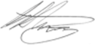

Gavin Armitage Technical Director

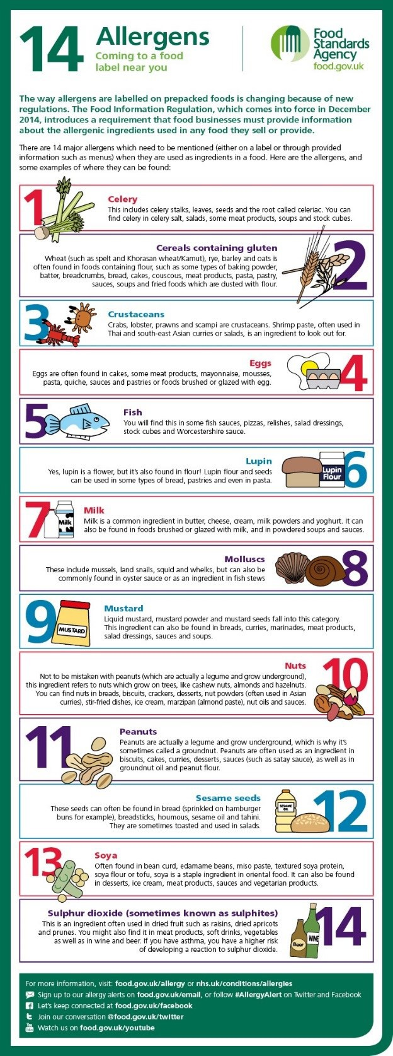
ALLERGENS EXPLAINED & OTHER DIETARY INFORMATION
Other dietary information | Yes | No
Free from salt and salt substitutes | ✓
Free from additives | ✓
Free from alcohol | ✓
Free from colours | ✓
Free from flavours | ✓
Free from preservatives | ✓
Free from Animal – Beef fats / Meats | ✓
Free from Animal – Duck Fats / Meats | ✓
Free from Animal – Lamb Fats / Meats | ✓
Free from Animal – Pork Fats / Meats | ✓
Free from Animal – Poultry Fats / Meats | ✓
Free from Animal Fats other than dairy fats | ✓
Free from antioxidants BHA/BHT | ✓
Free from Aspartane | ✓
Free From Barley / Derivatives | ✓
Free from Benzoates | ✓
Free from Caffeine | ✓
Free from fruit derivatives | ✓
Free from Dairy Products | ✓
Free from gelatine | ✓
Free from glutamate | ✓
Free from Maize / derivatives | ✓
Free from MSG | ✓
Free from Mushrooms / derivatives | ✓
Free from Modified Starch | ✓
Free from offal | ✓
Free from Potassium based salt substitutes | ✓
Free from Vegetable / Derivatives | ✓
Free from Yeast / Derivatives | ✓
Is the product suitable for :
Vegetarians | ✓
Vegans | ✓
Muslim / Halal Diet | ✓
Orthodox / Jewish/ Kosher Diet | ✓
Orthodox Hindus Diet | ✓
People with Nut/Seed Allergy | ✓
Coeliacs / People with gluten sensitivity | ✓

